

St Mary’s CofE

Primary Academy

Behaviour & Relationships
Principles & Procedures

Date: | September 2024
Approved by: | LGB
Review date: | September 2026
Signed by Headteacher:
Signed by Chair of Governors:

Philosophy

At we follow a therapeutic approach to developing positive behaviour in a variety of ways, aimed at developing internal discipline so that our children can go on to live successful lives as adults able to regulate their behaviour appropriately. We aim to teach positive behaviour rather than simply managing behaviour. We are committed to providing an inclusive environment in which individual needs and feelings are understood and supported.

We recognize that all behaviour is a communication, and we endeavor to recognize and understand the behaviour that an individual may exhibit. We seek to understand and respond to children on an individual level, ensuring personalized and consistent responses which enable children to learn to effectively manage their own behaviour. We believe that to create long term change we need to understand, not simply suppress, the behaviour an individual may demonstrate. We understand that positive, caring and trustworthy relationships are key to the success of our approach.
believe that positive experiences create positive feelings and positive feelings create positive behaviour.
For a therapeutic approach to be successful there needs to be a shared understanding and consistency among all members of the school community. This policy sets out that approach and all staff are expected to uphold the principles within.

All staff need to know how to promote pro-social behaviour and how to manage difficult or dangerous behaviour. They also need to have an understanding of what behaviour might be communicating. All staff should focus on de-escalation and preventative strategies rather than focusing solely on reactive strategies.

Strong school leadership
Governing Body is committed to supporting high standards of behaviour. The children will be able to voice their opinions about behaviour in school and help to shape the school policy. The head teacher will have a high profile amongst the children and develop positive relationships which will enable a more personal approach to dealing with unacceptable behaviour. The head teacher will support all staff in maintaining good discipline and will keep staff, parents and governors up to date with DfE, ACT and local guidance relating to behaviour in schools. Unacceptable behaviour will be dealt with promptly and effectively to ensure that learning is not
behaviour has due regard to the Equality Act, Special Educational Needs and safeguarding procedures.

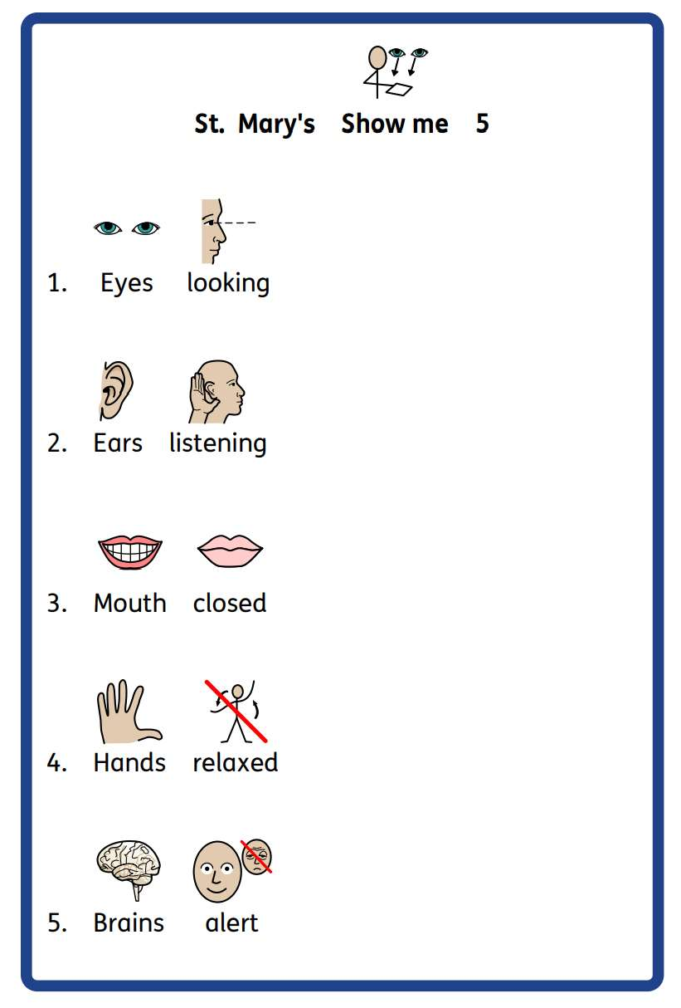
learning in the classroom, in the corridor or dining room, or on the playground. These expectations

adult showing a hand to engage children and remind them of the behaviour expected.

It is also used to focus praise, recognising children for showing one or more of the expected 5 behaviours.

It is understood that for some children, making eye contact is difficult. Staff are mindful of this when responding to children, but encourage children to look in the appropriate direction to focus their attention. Other children may use fiddle toys to support them in self-regulating, this is understood within the expectation of hands relaxed.

Classroom management
Classroom management is key to promoting positive behaviour. At we expect all classrooms to have:
A positive tone
Clear classroom rules/contracts displayed which have been agreed by the teacher and the class at the start of the year.
Clear expectations about work and work that is set at an appropriate level for the child A timetable so children know what is planned for the day
An attractive, tidy, well-cared for environment
A well-planned environment so that children can move easily, can find resources, property respected etc
Strategic seating arrangements if needed for children when working on the carpet or at a table Individually agreed approaches where necessary- agreed in consultation with the Headteacher.

Strategies
Strategies to acknowledge and encourage pro-social behaviour
Within the established positive learning environment, children should expect to receive regular praise from all they come into contact with. Strategies to acknowledge positive behaviour include:
Verbal praise and encouragement, including recognition where Non-verbal praise e.g. thumbs up
Written remarks about successes in learning (based on knowledge about the standard that can be expected for the individual)
Sending children to another teacher or Headteacher to share their work/positive behaviour
Learner of the Week certificates , social and
academic achievement)

Strategies to respond to and de-escalate anti-social behaviour
When a ge of strategies may be used:
Verbal and non-verbal reminders Quiet pause to refocus in class
Move place of work/ cooling off time
Positive phrasing about the desired behaviour- clear instructions, with repetition. This provides children with processing and take-up time.
Limited choices- this helps to encourage mutual respect and foster self-responsibility in the child; they are encouraged to choose from restricted choices so they do not feel that they have lost control over their actions.
Disempowering the behaviour-
Time away from the classroom to support self-regulation

Anti-bullying
The school believes that nobody has the right to hurt other people by hitting or kicking them, calling names, spreading rumors about them or by doing anything else which is intended to be upsetting.

All children have a right to learn in a supportive, caring and safe environment without fear of being bullied. Bullying is wrong and it will not be tolerated at
To support this principle, all children are told regularly, through class PSHE lessons and collective worship, that bullying may be verbal, physical or through the use of technology and will not be tolerated by the school in any form whatsoever. They are made aware that any repetitions or patterns of unkind behaviour will be treated as bullying and significantly, that speaking out is essential. Children are taught that being safe is the most important thing and that every child has the right to feel safe in our school.
Our Anti-bullying Policy takes into account guidance from the Equalities Act, the LA and the Church of England.

Playtimes
Behaviour during morning and afternoon break times is monitored by the staff on duty. Staff zone the playground area to ensure that adults are visible to the children at all times.
Staff on duty will handle minor issues and refer to if/when appropriate.

Lunchtime
Lunch times are the immediate responsibility of the midday supervisors.
We aim to reduce playground problems by ensuring staff are trained in positive behavioural management.
At lunchtimes the MDSs report major problems directly to the Headteacher. Minor incidents are reported directly to the class teacher if necessary.

Consequences


own internal discipline. It is important that they learn about the logical consequences of their behaviour.
Following an incident of unacceptable behaviour, a consequence may be given to the child.
This may be a protective consequence, aimed at managing the risk of harm, or an educational consequence, focused on teaching so that the incident does not occur again.
Educational consequences may include:
Completing work at later time (this may involve missed time during break/lunch time) Assisting with repairs
Research
Restorative meetings/writing a reflection/letter of apology Communication with parents

Protective consequences may include:

Time away from the classroom, a differentiated teaching space, being sent to the head or deputy.
Limited access to outside space (e.g. loss of break time) Exclusion
Staff are discouraged from using group sanctions, as these are unlikely to follow the approach of logical consequence.
Through working closely and openly with pupils and their families, it is our aim to resolve behavioral issues at the earliest possible stage.
Behavioral concerns are logged by staff members on MyConcern, and these records are reviewed regularly by the DSPs.

Post-incident recovery and restoration
Following an incident of unacceptable behaviour, we will work with the pupil to reflect, repair and restore relationships as appropriate. The purpose of this is to re-visit the experience by re-telling and exploring the situation with a changed set of feelings, in order to learn from it. This process will only be begun once those involved in an incident have had time to return to emotional equilibrium.
(e.g. through comic strip conversations, role play with puppets, exploration of feelings with anyone else involved), but it involves:
Telling the story of what happened
Exploring what people were thinking and feeling at the time Exploring who has been affected and how
Exploring how we can repair relationships
Summarising what we have learned so we are able to respond differently next time.

Pupil support systems
include:
A child who is withdrawn and unable to make friends A child who is unable to concentrate on classwork
A child who may become disruptive and / or aggressive in class

could

In such cases any emotional difficulties should be acknowledged. Pupils will be given the opportunity to express their thoughts and feelings with a chosen adult either individually or within a nurture group and non-verbal systems for communication may be tried.

Personalized plans
The Headteacher will assist with any persistent challenging behaviour in any context. Some children may require an individual approach that differs from the whole school code. An assessment of the
, with an aim to develop an understa
A number of tools may be used to support this process, including:
The gathering of ABCC (antecedent, behaviour, communication, consequence) charts to look triggers and patterns of behaviour
Anxiety maps
Roots and Fruits trees to explore the links between experiences, feelings and behaviour
A Predict and Prevent Plan, or Risk Management Plan may be formulated to formalise strategies for the individual that differentiate from policy. (See Appendix A) This will be developed in collaboration with parents and professionals, and agreed approaches will be based on pupil, parents and staff
-social behaviour and in de-escalating difficult behaviour. These Plans will ensure consistency of approach, and will be reviewed regularly in order to refine strategies as needed.
Further external support may be sought through the initiation of an Early Help Assessment.

Exclusion
failed, we will follow the guidance set out in the LA Exclusions Guidance. The Chair of the Local Governing Body and ACT will be informed if a decision is made to exclude.
As part of our positive behaviour strategy and depending upon the severity of a misdemeanor, the school expects to use supervised internal exclusions, including time for reflection and restoration, as much as possible before moving to the formal terms of the Exclusion Guidance.

Staff development and support
Part of the process of annually reviewing this policy involves all staff being reminded about practice and principles of promoting good behaviour whilst being able to contribute ideas to improving practice.
Induction for new staff will include training on the therapeutic approach adopted by the school. The Headteacher will ensure that staff are kept up to date with DfE publications and guidance.
The school will provide training for staff around the specific needs of pupils with behavioral needs
ild.
It is
is a child with challenging behaviour in their class. This can be done through offering advice, supporting the formulation of individual plans, and paying due regard to staff health and wellbeing, including the offer of de-brief sessions following difficult incidents, to allow staff to reflect and ask for any support needed.

Liaison with parents and other agencies
Working with parents is an important part of supporting children with their conduct. At we make sure that parents are informed of incidents involving their child, especially where this behaviour has been of a serious or of a continuous low-level nature.
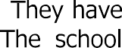
Parents are actively encouraged to be involve
acknowledges the importance of home school partnerships. This is strongly promoted through the sc school agreement whereby parents are encouraged to sign to show a commitment to the ethos and work of the school.

Physical intervention
Restrictive Physical Interventions will be used when all other strategies have been considered, and therefore only as a last resort. There are situations when Restrictive Physical Interventions may be
necessary, for example, in a situation of clear danger and extreme urgency. A risk assessment will be drawn up should physical intervention become a likely need for specific children and staff would be trained in the appropriate handling. Staff will take steps in advance to avoid the needs for restrictive physical intervention through dialogue and diversion. Staff will be able to show that the intervention used was a reasonable response to the incident.

Appendix A:
Individual Risk Management Plan
Name | DOB | Date | Review Date
Risk reduction measures and differentiated measures (to respond to triggers)

Photo

Pro social / positive behaviour | Strategies to respond
Anxiety / DIFFICULT behaviours | Strategies to respond
Crisis / DANGEROUS behaviours | Strategies to respond
Post incident recovery and debrief measures
Signature of Plan Co-

Signature of Young



