

St Mary’s C of E

Primary Academy

Behaviour & Relationships
Principles & Procedures
Date: | December 2025
Approved by: | LGB
Review date: | December 2026
Signed by Headteacher: | L. King
Signed by Chair of Governors: | Carol Way

St Mary’s “Show me 5”
At St. Mary’s we have consistent expectations of children across the school day, whether they are learning in the classroom, in the corridor or diming room, or on the playground. These expectations are easily remembered as the St. Mary’s “Show Me 5”:
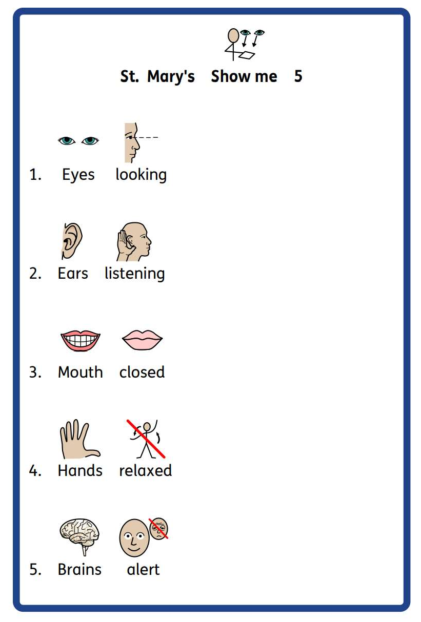
“Show me 5” is used with an adult showing a hand to engage children and remind them of the behaviour expected.
It is also used to focus praise, recognising children for showing one or more of the expected 5 behaviours.
It is understood that for some children, making eye contact is difficult. Staff are mindful of this when responding to children but encourage children to look in the appropriate direction to focus their attention. Other children may use fiddle toys to support them in self-regulating; this is understood within the expectation of hands relaxed.

Classroom management
Classroom management is key to promoting positive behaviour. At Saint Mary’s we expect all classrooms to have:
- A positive tone
- Clear classroom rules/contracts displayed which have been agreed by the teacher and the class at the start of the year.
- Clear expectations about work and work that is set at an appropriate level for the child
- A timetable so children know what is planned for the day
- An attractive, tidy, well-cared for environment
- A well-planned environment so that children can move easily, can find resources, property respected etc
- Strategic seating arrangements if needed for children when working on the carpet or at a table
- Individually agreed approaches where necessary- agreed in consultation with the Headteacher.

Strategies
Strategies to acknowledge and encourage pro-social behaviour
Within the established positive learning environment, children should expect to receive regular praise. Strategies to acknowledge positive behaviour include:
Verbal praise and encouragement, including recognition where children have “shown 5”
- Non-verbal praise, e.g. thumbs up
- Written remarks about successes in learning (based on knowledge about the standard that can be expected for the individual)
- Sending children to another teacher or the Headteacher to share their work/positive behaviour
- Displaying pupils work and achievements
- Learner of the Week certificates to celebrate children’s success (for behaviour, social and academic achievement)
- Headteacher Awards to celebrate children’s successes (Social, Emotional and Academic)
Strategies to respond to and de-escalate anti-social behaviour
When a pupil’s behaviour falls below and acceptable standard, a range of strategies may be used:
- Verbal and non-verbal reminders
- Quiet pause to refocus in class
- Move place of work/cooling-off time
- Positive phrasing about the desired behaviour – clear instructions, with repetition. This provides children with processing and take-up time.
- Limited choices – this helps to encourage mutual respect and foster self-responsibility in the child; they are encouraged to choose from restricted choices, so they do not feel that they have lost control over their actions.
- Disempowering the behaviour – this may include tactical “ignoring” of unwanted behaviour, “catching them getting it right” at the earliest opportunity and moving them to a different place within the classroom.
- Time away from the classroom to support self-regulation
Anti-bullying
The school believes that nobody has the right to hurt other people by hitting or kicking them, calling names, spreading rumours about them or by doing anything else which is intended to be upsetting.
All children have a right to learn in a supportive, caring and sage environment without fear of being bullied. Bullying is wrong and it will not be tolerated at St. Mary’s C of E Primary Academy.
To support this principle, all children are told regularly, though class PSHE lessons and collective worship, that bullying may be verbal, physical or through the use of technology and will not be tolerated by the school in any form whatsoever. They are made aware that any repetitions or patterns of unkind behaviour will be treated as bullying and significantly, that speaking our is essential. Children are taught that being safe is the most important thing and that every child has the right to feel safe in school.
Playtimes
Behaviour during morning and afternoon break times is monitored by the staff on duty. Staff are always visible to the children.
Staff on duty will handle minor issues and refer to the child’s class teacher if/when appropriate.
Lunchtime
- We aim to reduce playground problems by ensuring staff are trained in positive behavioural management.
- At lunchtimes staff report major problems directly to the Headteacher.
- Minor incidents are reported directly to the class teacher if necessary.
Consequences
Our approach to developing the best behaviour for all children is based on developing each child’s own internal discipline. It is important that they learn about the logical consequences of their behaviour.
Following an incident of unacceptable behaviour, a consequence may be given to the child. This may be a protective consequence, aimed at managing the risk of harm, or an educational consequence, focused on teaching so that the incident does not occur again.
Educational consequences may include:
- Completing work at later time (this may involve missed time during break/lunch time)
- Assisting with repairs
- Research
- Restorative meetings/writing a reflection/letter of apology
- Communication with parents
Protective consequences may include:
- Time away from the classroom, a differentiated teaching space, being sent to the headteacher
- Limited access to outside space (e.g. loss of break time)
- Suspension
- Exclusion
Through working closely and openly with pupils and their families, it is our aim a St. Mary’s to resolve behavioural issues at the earliest possible stage.
Behavioural concerns are logged by staff members on My Concern, and these records are reviewed regularly by the DSPs.
Post-incident recovery and restoration
Following an incident of unacceptable behaviour, we will work with the pupil to reflect, repair and restore relationships as appropriate. The purpose of this is to re-visit the experience by re-telling and exploring the situation with a changed set of feelings, to learn from it. This process will only start once those involved in an incident have had time to return to emotional equilibrium. The process may be completed in a variety of ways, appropriate to the child’s age and learning style (e.g. through comic strip conversations, role play with puppets, exploration of feelings with anyone else involved), but it involves:
- Telling the story of what happened
- Exploring what people were thinking and feeling at the time
- Exploring who has been affected and how
- Exploring how we can repair relationships
- Summarising what we have learned so we are able to respond differently next time.
Pupil support systems
At St. Mary’s C of E Primary Academy, staff are trained to look our for changes in behaviour which could include:
- A child who is withdrawn and unable to make friends
- A child who is unable to concentrate on classwork
- A child who may become disruptive and / or aggressive in class
In such cases any emotional difficulties should be acknowledged. Pupils will be given the opportunity to express their thoughts and feelings with a chosen adult either individually or within a nature group and non-verbal systems for communication may be tried.
Personalized plans
The Headteacher will assist with any persistent challenging behaviour in any context. Some children may require an individual approach that differs from the whole school code. An assessment of the child’s needs is undertaken, with an aim to develop an understanding of the child’s behaviour.
A number of tools may be used to support this process, including:
- The gathering of ABCC (antecedent, behaviour, communication, consequence) charts to look triggers and patterns of behaviour
- Anxiety maps
- Roots and Fruits trees to explore the links between experiences, feelings and behaviour
A Risk Management Plan may be formulated to formalise strategies for the individual that differentiate from policy (see Appendix A). This will be developed in collaboration with parents and professionals, and agreed approaches will be based on pupil, parents and staff views about what works/doesn’t work in promoting pro-social behaviour and in de-escalating difficult behaviour. These Plans will ensure consistency of approach and will be reviewed regularly to refine strategies as needed.
Further external support may be sought through the initiation of an Early Help Assessment.
Exclusion
Where a child’s behaviour causes significant concern and the range of strategies outline above has failed, we will follow the guidance set out in the LA Exclusions Guidance. The Chair of the Local Governing Body and ACT will be informed if a decision is made to exclude.
As part of our positive behaviour strategy and depending upon the severity of a misdemeanour, the school expects to use supervised internal exclusions, including time for reflection and restoration, as much as possible before moving to the formal terms of the Exclusion Guidance.
Staff development and support
- Part of the process of annually reviewing this policy involves all staff being reminded about practice and principles of promoting good behaviour whilst being able to contribute ideas to improving practice.
- Induction for new staff will include training on the therapeutic approach adopted by the school.
- The Headteacher will ensure that staff are kept up to date with DfE publications and guidance.
- The school will provide training for staff around the specific needs of pupils with behavioural needs. This will form part of our ‘package’ for support and intervention for that child.
- It is the Governors and Headteacher’s responsibility to support staff, particularly when there is a child with challenging behaviour in their class. This can be done through offering advice, supporting the formulation of individual plans, and paying due regard to staff health and wellbeing, including the offer of de-brief sessions following difficult incidents, to allow staff to reflect and ask for any support needed.
Liaison with parents and other agencies
Working with parents is an important part of supporting children with their conduct. At St. Mary’s we make sure that parents are informed of incidents involving their child, especially where this behaviour has been of a serious or of a continuous low-level nature.
Parents are actively encouraged to always be involved in their children’s education, and the school acknowledges the importance of home school partnerships. This is strongly promoted through the school’s home-school agreement whereby parents are encouraged to sign to show a commitment to the ethos and work of the school.

Physical intervention
Restrictive Physical Interventions will be used when all other strategies have been considered, and therefore only as a last resort. There are situations when Restrictive Physical Interventions may be necessary, for example, in a situation of clear danger and extreme urgency. A risk assessment will be drawn up should physical intervention become a likely need for specific children and staff would be trained in the appropriate handling. Staff will take steps in advance to avoid the needs for restrictive physical intervention through dialogue and diversion. Staff will be able to show that the intervention used was a reasonable response to the incident.

Appendix A:
Individual Risk Management Plan
Name | DOB | Date | Review Date
Photo | Risk reduction measures and differentiated measures (to respond to triggers)
Pro social / positive behaviour | Strategies to respond
Anxiety / DIFFICULT behaviours | Strategies to respond
Crisis / DANGEROUS behaviours | Strategies to respond
Post incident recovery and debrief measures

Signature of Plan Co-ordinator ________________________________ Date: _________________________
Signature of Parent / Carer ___________________________________ Date: __________________________
Signature of Young Person ___________________________________ Date: __________________________

