

Allergy Policy

Name of Policy/Procedure | Allergy Policy
Author | Rebecca Bliss
Version | 1
Applicable to | All schools in ACT MAT
Approved by: | Trust Board
Approved on: | 02.10.2026
Review Cycle | Annual
Date of next review | September 2027
Website Publication yes/no | Yes-Trust and School

KEY CONTACTS
School Name | St Marys CofE Primary Academy
Safeguarding Lead | Lisa king
Medical Staff | First Aid trained:  - Sally Staughton  - Leisl Leite  - Charlotte Bailey  - Lisa king  - Lucy Sanders
Catering Staff | Mrs Sue Fairbrass
This Policy supersedes any previous Policy of this name or instructions that pre-date this edition.

This policy is a Trust Wide policy which has been adapted for each school within ACT MAT. It was devised following advice from Allergy School and The Natasha Allergy Research Foundation. This
policy draws on the work of the wider allergy sector including information from the British Society for Allergy & Clinical Immunology (BSACI), whose resources are an invaluable asset for schools and
parents.

Contents

Statement of Intent p4
Equalities Statement p4
Context p4
Principles p5
Allergy Management Checklist p5
Practical Steps p6
Supply, storage and care of medication p11
Catering p12
Allergy awareness and nut bans p13
Risk assessment p13
Training p13
Allergies and bullying p14

Appendix I - First Aid for Anaphylaxis poster Appendix II - Epipen AAI and Jext AAI Instructions
Appendix III - Flowchart for Allergic Reaction without use of Adrenaline Auto-Injector Appendix IV - Flowchart for Allergic Reaction with use of Adrenaline Auto-Injector Appendix V - Information on Allergies
Appendix VI - Other Support and Resources Appendix VII - Top 14 Allergens poster

Statement of intent

This School is committed to promoting a whole school approach to health care, welfare and wellbeing and the safe management of those members of our school community who live with specific allergies. We believe that all allergies should be taken seriously and dealt with in a professional and appropriate way. By our actions we will work proactively to:
- minimise the risk of exposure within the school setting
- encourage self-responsibility
- learn avoidance strategies
- have robust plans for an effective response to possible emergencies
- ensure inclusivity for all pupils

Equalities statement

Our school is clear about the need to actively support pupils with medical conditions to participate in school life.
The school will consider what reasonable adjustments need to be made to enable these pupils to participate fully and safely in all aspects of school life.
Risk assessments will be carried out so that planning arrangements take account of any steps needed to ensure that pupils with medical conditions are included. In doing so, pupils, their parents and any relevant healthcare professionals will be consulted.

Context

Food allergies are increasing in both developed and developing countries, especially in children and the severity and complexity of food allergy is also increasing. Food allergy can be fatal and an appropriate diagnosis is essential in parallel with the need for clear food labelling worldwide.
Around 5-8% of children in the UK live with a food allergy and most school classrooms will have at least one allergic pupil. These young people are at risk of anaphylaxis, a potentially life-threatening reaction which requires an immediate emergency response. 20% of severe allergic reactions to food happen whilst a child is at school and these reactions can occur in children with no prior history of food allergy. It is essential that staff recognise the signs of an allergic reaction, symptoms and are able to manage it safely and effectively.
Schools have a legal duty to support pupils with medical conditions, including allergy.

Principles

- To comply with all relevant environmental legislation, regulations and requirements.
- To encourage proactive steps to keep pupils safe.
- To ensure pupils from diverse backgrounds, ethnicities or different cultural heritages are not disadvantaged when dealing with allergies and food labelling.
- To work with the catering team to establish a robust process and documentation for menu planning, food labelling, storing, avoidance of cross-contamination, stock ordering of food/drink used at the school.
- To provide an effective staff awareness programme on food allergies and intolerances, possible symptoms (anaphylaxis) recognition and actions to take.
- To develop a pupil awareness programme through PSHE and other curriculum areas.

Allergy management checklist

- Does the child have an Individual Healthcare Plan
- Has your school purchased spare pens?
- Does each child have a completed and signed Allergy Action Plan?
- Have ALL school staff been trained in allergy and anaphylaxis?
- Does the school allergy policy include where and how to store AAIs?
- Is there a schedule to check the expiry dates on spare AAIs and each child’s AAI?
- Does the allergy policy cover catering for children with allergies?
- Does the allergy policy include pupil allergy awareness?
- Has the school completed an allergy risk assessment?
- Does the allergy policy include risk assessment of extra curricula activities?
- Does the allergy policy cover safeguarding children with allergies, including bullying?

Practical steps (see also Appx I and Appx II)

In order to put these principles into practice we will:

Governors and Trustees
- Ensure the school has a strategic vision for the management of allergy risk assessment and emergency procedures
- Delegate the day-to-day responsibility for the effective delivery of this Policy to the Headteacher
- Ensure the school’s arrangements to identify and safeguard the wellbeing of pupils, because of their own or someone else’s allergy, are robust and effective
- Ensure that the school provides appropriate training, information, instruction, induction and supervision on a regular basis to enable everyone to stay safe regarding allergies and their management. It is good practice to log all training and attendees.
- Ensure adequate resources for managing allergies are available
- Ensure appropriate material is available on the school website for parent/carers highlighting how the school is managing pupils with allergies
- Monitor the effectiveness of this Policy to ensure it remains fit for purpose

Headteacher
- Provide, as far as practicable, a safe and healthy environment in which people at risk of
allergic reaction and anaphylaxis can participate equally in all aspects of school life and are not subject to bullying because of their condition
- Ensure all visitors, volunteers, work experience students, sub-contractors are made aware of the school’s commitment to allergy management as part of Safeguarding
- Ensure the curriculum contains age-appropriate content so all pupils can learn about allergies and how everyone can support those who have them
- Create links at strategic level with Healthcare professionals and Catering providers and ensure at operational level that links are robust
- Ensure that up-to-date allergy information for pupil is accessible to catering teams.
- Ensure there is a workable School Emergency Plan in place that is known by all staff
- Ensure the school sends a copy of the medical details it holds for the child to parents/carers for review and update at the end of each school year. Seek updated medical information at the commencement of each calendar year and for any pupil joining in year
- Where the pupil has an Individual Healthcare Plan (IHP), ensure the involvement of healthcare and welfare professionals, teaching and catering staff, parents/carers and the pupil in establishing IHPs.
- Encourage parents/carers to provide Allergy Action Plans (AAPs) completed and signed by a healthcare professional that can be kept with their medication with copies made available for all staff to access and help the school support the pupil

- Ensure effective communication of individual pupil medical needs to all staff and that they know how and where to check for updated information.
- Ensure there are enough trained staff to meet the statutory requirements and assessed needs, allowing for staff absences away from the school premises
- Ensure First Aid staff training includes anaphylaxis management, including awareness of triggers, anaphylaxis and first aid emergency procedures
- Ensure an adequate risk assessment is undertaken prior to any school trips, excursions or off-site extra curricula activities for pupils who have allergies
- Ensure records of pupils medically prescribed an AAI and its use are kept correctly
- Ensure pupil documentation and in date medication is kept correctly and safely
- Ensure best practice in the labelling of foodstuffs and their contents
- Report to the Board of Governors regarding the management of allergies within the school

Member(s) of Staff responsible for medical needs
- Follow all legal requirements, recommended best practice and whole school procedures pertaining to allergies within the school context
- Report to the Head regarding pupils with allergies
- Lead on the training of staff regarding allergy medical needs and their identification and management
- Work closely with in-house and sub-contracted Catering Managers and Chef Managers in assisting in the support of pupils with known allergies (including meeting with
parents/carers where requested) to discuss any special requirements
- Monitor where there is a school ‘bake sale’ or home baked items are brought into school
- Liaise with parents/carers of pupils with known declared allergies to produce a risk assessment for their child that includes sharing of information, allergy management, risk minimisation and emergency actions.
- Wherever possible use an AAP for pupils with recognised allergies and keep it with their medication. Ensure copies of the AAP are available for all staff to access.
- If an additional written IHP is not required, ensure that the AAP is viewed and treated with the same level of seriousness.
- Ensure all copies of the AAP/IHP located around the school and/or on IT systems are identical if an updated version is received.
- Where an AAP has not been received for a pupil with recognised allergies, or if the medication information is not clear, liaise with GP/school nursing team, to obtain an up-to-date copy and/ or clarification.
- Ensure medication is stored in a rigid box and clearly labelled with the pupil’s name and a photograph (older students should carry their AAIs and medication with them)

- Be trained in the use of an Adrenaline Auto-Injector (AAI) and be competent in performing any possible required prescribed medical treatment as outlined in the pupil’s IHP and/or AAP
- Ensure that any other staff involved with those pupils requiring the use of an AAI are also adequately trained and competent
- Ensure all school trips, excursions or off-site extra curricula activities for pupils are pre-checked so that ‘safe’ food is provided or that an effective control is in place to minimise risk of exposure for pupils with allergies
- Ensure the school has an audited spare supply of in date AAIs that are kept in a safe space at room temperature that is accessible, secure but not locked away and all staff are aware of the location
- Monitor the use of all AAIs to ensure they are within the expiry date including those brought into the school by pupils or external sources and are of the correct dosage
- Arrange for the correct disposal of out-of-date AAIs
- Where anaphylaxis is suspected in an undiagnosed individual, call the emergency services
and state ANAPHYLAXIS is suspected, then follow their advice as to whether administration of a spare AAI is appropriate
- Record all emergency uses of AAIs or reports of suspected emergencies
- Ensure that, if a pupil notifies school that they are no longer allergic to a food, this information is checked prior to updating records and the IHP (if applicable).

All Staff
- Follow as directed all the requirements of the school, including all legal requirements,
recommended best practice and whole school procedures pertaining to allergies within the school context
- Complete appropriate anaphylaxis training and be confident to respond to an allergy emergency
- Raise awareness about allergies and anaphylaxis amongst their pupils in the classroom and around school, especially in dining areas
- Encourage self-responsibility and learned avoidance strategies amongst pupils living with allergies
- Help all pupils understand which foods are safe for those with allergies and how they can support other pupils with specific dietary needs to stay safe
- Highlight the need for anti-bullying of pupils with the condition
- Be aware of the pupils in their care (including regular cover classes) who have known allergies as an allergic reaction could occur at any time, not just at breaks or mealtimes
- Any food-related activities must be supervised with due caution whilst following best practice for storing, preparing, cooking and serving food
- Any staff leading on a school trip must check that all pupils with medical conditions, including allergies, are carrying their medication (those unable to produce their required medication

would not be able to attend the excursion)
- Staff leading a school trip, excursion or off-site extra curricula activity must ensure they carry all relevant emergency supplies with them

Parents/Carers
- Notify the school of the pupil allergies.
- Inform the school of any changes as soon as known
- Talk with your child about allergy self-management, including what foods are safe and unsafe, how to read food labels, strategies for avoiding allergens, how to spot symptoms of allergy, how and when to tell an adult if experiencing an allergic reaction.
- Provide an AAP completed by a healthcare professional that can be kept with their medication and help the school support the pupil
- Contribute to the provision of an IHP in partnership with the school, and relevant healthcare professional, where required.
- Provide any other written medical documentation, instructions and medications as directed by a health professional.

If you require it, meet with the Catering Manager to discuss any specific requirements relating to your child’s allergy (information from these meetings will be recorded by the Catering Manager)
- Be aware of the school Allergy Policy and any arrangements for managing children with allergies and at risk of anaphylaxis
- Communicate regularly with the school to support our ability to keep our children safe and act immediately in the event of an allergic reaction
- Provide appropriate in date medication (two AAIs) of the correct dosage and register their AAIs on the manufacturer’s websites to receive text alerts for expiry dates
- Providing appropriate foods to be consumed by the child if necessary
- Replace medications after use or upon expiry
- Review the Policy and procedures with the school’s Head responsible for medical needs, the pupils doctor and the pupil (if age appropriate) after a reaction has occurred

Pupils with allergies (as age appropriate)
- Have a good awareness of their allergy and support the knowledge of peers in helping keep them safe
- Be proactive in the care and management of their food allergies and reactions and medication
- Be sure not to exchange food with others and take care to avoid any foods which may cause an allergic reaction
- Read food labelling but, if unsure, avoid the food
- Avoid eating anything with unknown ingredients
- Know where their medication is kept and (if age appropriate and confident enough to administer their own auto-injectors) take responsibility for carrying AAIs on their person at all times
- As soon as they suspect they are experiencing signs of allergic reaction, tell an adult.

Supply, storage and care of medication

Depending on their level of understanding and competence, pupils will be encouraged to take responsibility for and to carry their own two AAIs on them at all times (in a suitable bag/container). The suggested age range for this would be from Year 4 upwards in most cases.
For younger children or those not ready to take responsibility for their own medication, there should be an anaphylaxis kit which is kept safely, not locked away and accessible to all staff.
Medication should be stored in a suitable container and clearly labelled with the pupil’s name. The pupil’s medication storage container should contain:
- Two AAIs i.e. EpiPen® or Jext®
- An up-to-date allergy action plan
- Antihistamine as tablets or syrup (if included on allergy action plan)

- Spoon if required
- Asthma inhaler (if included on allergy action plan).
It is the responsibility of the child’s parents to ensure that the anaphylaxis kit is up-to-date and clearly labelled, however the School First Aider Team will check medication kept at school on a termly basis and send a reminder to parents if medication is approaching expiry.
Parents can subscribe to expiry alerts for the relevant AAIs their child is prescribed, to make sure they can get replacement devices in good time.

Storage
AAIs should be stored at room temperature, protected from direct sunlight and temperature extremes.

Disposal
AAIs are single use only and must be disposed of as sharps. Used AAIs can be given to ambulance paramedics on arrival or can be disposed of in a pre-ordered sharps bin. Sharps bins to be obtained from and disposed of by a clinical waste contractor.

The sharps bin is kept in the following room: Medical Room

Spare AAIs
Schools can now legally purchase and store spare Adrenaline Auto-Injectors (AAIs For children at risk of anaphylaxis). Immediate access to an AAI can be life-saving. While it’s vital that families have their own prescribed AAIs for their child, having spare AAIs at school adds an extra layer
of reassurance for everyone involved. It’s a step towards creating a safer and more inclusive
environment for children managing severe allergies.
Spare AAI’s will be kept in a central position in the school office.

Catering

All food businesses (including school caterers) must follow the Food Information Regulations 2014 which states that allergen information relating to the ‘Top 14’ allergens must be available for all food products.
The school menu is available for parents to view in advance with all ingredients listed and allergens highlighted on the school website.

The Headteacher and/or Safeguarding Team will inform the Catering Manager of pupils with food allergies.
The school should have a system in place to ensure catering staff can identify pupils with allergies e.g. a list with photographs– this information is held in Arbor and School Grid.

Parents/carers are encouraged to meet with the Catering Manager to discuss their child’s
needs.
The school adheres to the following Department of Health guidance recommendations:
- Bottles, other drinks and lunch boxes provided by parents for pupils with food allergies should be clearly labelled with the name of the child for whom they are intended.
- If food is purchased from the school kitchen, parents should check the appropriateness of foods by speaking directly to the catering manager.
- The pupil should be taught to also check with catering staff, before purchasing food or selecting their lunch choice.
- Where food is provided by the school, staff should be educated about how to read labels for food allergens and instructed about measures to prevent cross contamination during the handling, preparation and serving of food. Examples include: preparing food for children with food
allergies first; careful cleaning (using warm soapy water) of food preparation areas and utensils. For further information, parents/carers are encouraged to liaise with the Catering Manager.
- Food should not be given to food-allergic children without parental engagement and permission (e.g. birthday parties, food treats).
- Use of food in crafts, cooking classes, science experiments and special events (e.g. fetes, assemblies, cultural events) needs to be considered and may need to be restricted/risk assessed depending on the allergies of particular children and their age.

Allergy awareness and nut bans

The School supports the approach advocated by many allergy charities towards nut bans/nut free schools. They would not necessarily support a blanket ban on any particular allergen in any establishment, including in schools. This is because nuts are only one of many allergens that could affect pupils, and no school could guarantee a truly allergen free environment for a child living with food allergy. They advocate instead for schools to adopt a culture of allergy awareness and education.
A ‘whole school awareness of allergies’ is a much better approach, as it ensures teachers, pupils and all other staff are aware of what allergies are, the importance of avoiding the pupils’ allergens, the signs & symptoms, how to deal with allergic reactions and to ensure policies and procedures are in place to minimise risk.

Risk assessment

The School will conduct a detailed individual risk assessment for all new joining pupils with allergies and any pupils newly diagnosed, to help identify any gaps in our systems and processes for keeping allergic children safe.
Wiltshire Children Trust - Anaphylaxis Risk Assessment Example Template.

Training

Training should include a basic understanding of allergic disease and its risks which include:
- Knowing the common allergens and triggers of allergy
- Spotting the signs and symptoms of an allergic reaction and anaphylaxis. Early recognition of symptoms is key, including knowing when to call for emergency services
- Administering emergency treatment (including AAIs) in the event of anaphylaxis
- knowing how and when to administer the medication/device
- Measures to reduce the risk of a child having an allergic reaction e.g. allergen avoidance
- Knowing who is responsible for what
- Associated conditions e.g. asthma
- Managing Allergy Action Plans and ensuring these are up to date

Allergies and bullying

The school has a Relationships policy in place that includes measures to prevent all forms of bullying among pupils, and this is a policy decided by the school. All teachers, pupils and parents must be told what it is, and allergy bullying should be treated seriously, like any other bullying. Schools must, under Section 100 of the Children and Families Act 2014, aim to ensure that all children with medical conditions, in terms of both physical and mental health, are properly supported in school so that they can play a full and active role in school life, remain healthy and achieve their academic potential.
The Department for Education has provided statutory guidance for schools and colleges on keeping children safe in education. Please view the guidance here.
Other useful websites include:
- NSPCC
- National Bullying Helpline
- Family Lives
- Kidscape
- Anti-Bullying Alliance
- Young Minds
- Childline
- Bully Busters

Appendix I - First Aid for Anaphylaxis poster

FIRST AID
FOR ANAPHYLAXIS
Recognise the Signs of Anaphylaxis...

Airways
  - Persistent cough
  - Hoarse voice
  - Difficulty swallowing
  - Swollen tongue

Breathing
  - Difficult or noisy breathing
  - Wheeze or
persistent cough

Circulation
    - Persistent dizziness
    - Pale or floppy
    - Suddenly sleepy
    - Collapse/unconscious

An allergic reaction can escalate to anaphylaxis which is potentially life-threatening.
Always consider anaphylaxis in a food-allergic person even if there are no signs of a rash, hives or swelling.
ANAPHYLAXIS: ACTIONS TO TAKE
If any one or more of the above ABC symptoms are present, take these steps.

- Administer an Adrenaline Auto Injector (AAI) without delay
Inject the AAI into the top of the outer thigh. If you’re
in doubt that it is anaphylaxis but one or more ABC
symptoms
are present, give the AAI, it will not harm them.
- Dial 999 and say anaphylaxis (‘ana-fill-axis’)
Stay with the person until the ambulance arrives. DO NOT let them stand up and walk around.

- The person should lie down immediately
If the person is not already lying down, they should do so, with legs raised if possible. If breathing is difficult,
allow them to sit. If they have vomited or feel
sick, gently turn them on their side.

- Inject a second AAI into the

outer thigh if there are no signs of improvement after 5 minutes
If there is no sign of life, start CPR immediately until help arrives.




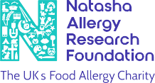

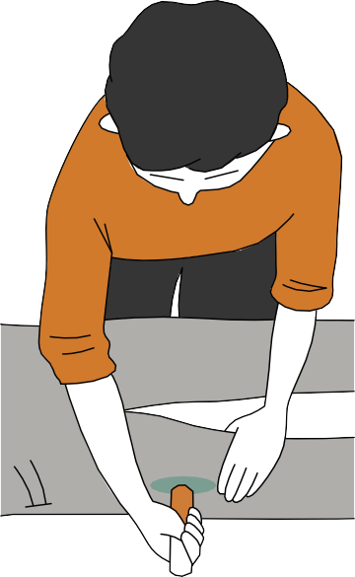
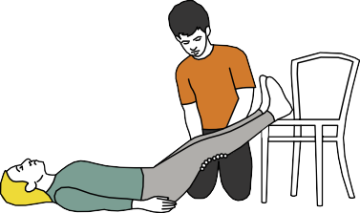
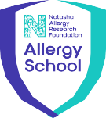
Please learn these steps. This is life-saving information.

Empower • Include • Protect

Appendix II - Epipen AAI and Jext AAI Instructions

ANAPHYLAXIS HOW TO USE EPIPEN AAIS
If you think someone is have an anaphylactic reaction, give the AAI without delay. It will not harm them.
Always consider anaphylaxis in a food-allergic person even if there are no signs of a rash, hives or swelling.

- Remove the blue safety cap
Grasp the EpiPen in your dominant hand and remove the blue safety cap by pulling straight up. Remember:
Blue to the Sky, Orange to the Thigh!

- Position the orange tip
Hold the EpiPen at 90°, approximately 10cm away from
the leg, with the orange tip pointing towards the outer thigh.

- Administer the EpiPen AAI
Jab the EpiPen firmly into the outer thigh at
a right angle. 3s Hold firmly for 3
seconds, before
removing and safely discarding.

- Once the EpiPen AAI has been

administered call 999
Ask for an ambulance and say

“ana-fill-axis”.
Lie the person down with legs raised immediately
If the person is not already lying down, they should do so, with
legs raised if possible.
If breathing is difficult, allow them to sit. If they have vomited or feel sick, gently turn them on their side .

- If there are no signs of improvement after 5 minutes, use a second EpiPen AAI
The person should remain still and lying down until the ambulance arrives. Don’t try to get up, even if you start to feel better.

- Start CPR
If there are no signs of life, start CPR immediately
until help arrives.

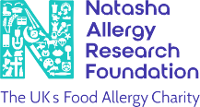
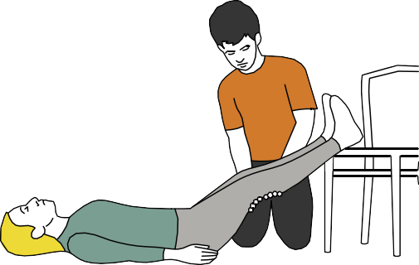
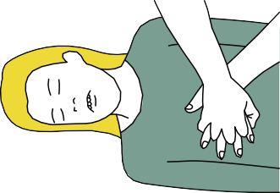
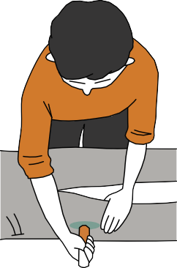


Appendix II - Epipen AAI and Jext AAI Instructions
ANAPHYLAXIS HOW TO USE JEXT AAIS
If you think someone is have an anaphylactic reaction, give the AAI without delay. It will not harm them.
Always consider anaphylaxis in a food-allergic person even if there are no signs of a rash, hives or swelling.

- Hold the Jext AAI in the hand you write with
Hold with your thumb closest to the yellow cap. Pull off the
yellow cap with your other hand.

- Place the black injector tip against the outer thigh
Hold the injector at a right angles (approx. 90°) to the thigh.

- Push the black tip as hard as you can into the outer thigh
Wait until you hear a ‘click’ confirming the injection has started, then keep it pushed in. Hold the injector firmly in place
against the thigh for 10 seconds (a slow count to
10) then remove. The black tip will extend automatically and hide the needle.

- Massage the injection area for 10 seconds

Once the Jext AAI has been administered call 999
Ask for an ambulance and say “ana-fill-axis”.

- Lie the person down with legs raised immediately
If the person is not already lying down, they should do so, with legs raised if possible.
If breathing is difficult, allow them to sit. If they have vomited or
feel sick, gently turn them on their side.

- If there are no signs of improvement after 5 minutes, use a second Jext AAI
The person should remain still and lying down until the ambulance arrives. Don’t try to get up, even if you start to feel better.

- Start CPR
If there are no signs of life, start CPR
immediately until help

For more information
arrives.

Sign up to the free expiry alert service

on Jext AAIs >>
and receive reminders by text or email when your Jext AAi is about to expire >>

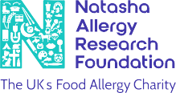

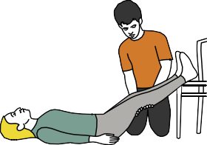
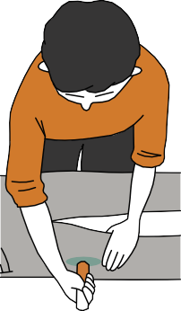

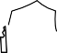
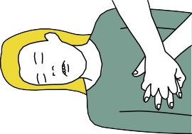



Empower • Include • Protect AllergySchool.org.uk

Appendix III

Flowchart for Allergic Reaction without use of Adrenaline Auto-Injector.
Refer to the child’s BSACI Allergy Action Plan if they have one and call for other staff help if needed

Mild Reaction
- Itchy skin, rash, hives
- Swelling of lips, throat
- Sneezing, nasal congestion
- Water, red eyes

Give Antihistamine Dose
- Check correct dose as on pharmacy label
Severe Reaction
- Hives (asthma or eczema worsen)
- Swollen tongue or difficulty swallowing
- Hoarse voice, coughing or wheezing
- Laboured breathing, gasping
- Stomach pain, bloating, vomiting
- Change in skin tone/colour - paler
- Feeling faint, clammy
- Dizziness, fainting, collapse

Contact Parent / Carer
- Notify them that their child has had an allergic reaction
- Supervise child continually
Where Airway / Breathing difficulty
ensure child sits upright
Where Feeling faint or drowsy,
lie down with legs raised

- If child vomits within 30 minutes of being ghiven first antihistamine dose
Administer another full dose

Regular dosing of antihistamine for 24 hours
- Dosage as directed on pharmacy label

If condition worsens move to Severe Reaction

Dial 999 immediately
- Follow instructions given by ambulance control staff
- Inform ambulance control if you have spare in-date Adrenaline Auto-Injectors at the School
- Ensure parents/carers are contacted
- DO NOT LEAVE THE CHILD
- If the child is asthmatic but still
alert, give inhaler via spacer - 2 puffs, additional puffs (1 per minute to max 8) can be given if needed.

Appendix IV

Flowchart for Allergic Reaction with use of Adrenaline Auto-Injector.
Refer to the child’s BSACI Allergy Action Plan if they have one and call for other staff help if needed

Mild Reaction
  - Itchy skin, rash, hives
  - Swelling of lips, throat
  - Sneezing, nasal congestion
  - Water, red eyes

Give Antihistamine Dose
  - Check correct dose as on pharmacy label
Severe Reaction
  - Hives (asthma or eczema worsen)
  - Swollen tongue or difficulty swallowing
  - Hoarse voice, coughing or wheezing
  - Laboured breathing, gasping

  - Stomach pain, bloating, vomiting
  - Change in skin tone/ colour - paler
  - Feeling faint, clammy
  - Dizziness, fainting, collapse

Contact Parent / Carer
    - Notify them that their child has had an allergic reaction
    - Supervise child continually
Where Airway / Breathing difficulty
ensure child sits upright
Where Feeling faint or drowsy,
lie down with legs raised

Administer Auto-Injector (AAI)

    - If child vomits within 30 minutes of being ghiven first
antihistamine dose
Administer another full dose

Regular dosing of antihistamine for 24 hours
    - Dosage as directed on pharmacy label

If condition worsens move to Severe Reaction
    - Check in-date, safety cap intact
    - Remove safety cap
    - Hold needle firmly, inject into thigh

Dial 999 immediately
    - Follow instructions given by ambulance control staff
    - Where no
improvement after 5 minutes, administer a second dose
    - Ensure parents/carers are contacted
    - DO NOT LEAVE THE CHILD
  - AAI clicks, hold for 3 seconds
  - Remove AAI carefully
  - Send for 2nd AAI

  - If the child is asthmatic but still alert, give inhaler via spacer - 2 puffs, additional puffs (1 per minute to max 8) can be given if needed.
  - Hand over AAIs to ambulance crew on
arrival or ambulance

Appendix V

Information on allergies
The most common causes of food allergies relevant to this Policy are the fourteen food allergens:

    - Cereals containing Gluten
    - Celery
    - Crustaceans
    - Eggs
    - Fish
    - Soya
    - Milk
    - Nuts
    - Peanuts
    - Mustard
    - Sesame Seeds
    - Sulphur dioxide/Sulphites
    - Lupin
    - Molluscs

However, it is possible that any food has the potential to cause an allergic reaction. Contact with any food or materials containing a child’s allergen has the potential to cause an allergic reaction for that child.
Latex, chemicals, medicines, grasses, pollen, weeds, trees, pets, insect venom and animal dander (shedded flakes of skin) can also cause allergic reactions.

Symptoms
Mild to moderate symptoms include:
    - Swelling of the eyes, face and lips
    - Runny or congested nose
    - Raised itchy rash (hives), eczema flare, skin flushing
    - Itchy mouth
    - Stomach cramps, nausea, vomiting, diarrhoea

Severe symptoms include:
    - Swollen tongue, hoarse voice or cry, difficulty swallowing and talking
    - Chest tightness
    - Breathing difficulties, persistent cough, wheeze
    - Low blood pressure, feeling faint, collapse
    - Pale and floppy (babies and small children)

Appendix VI

Other support and resources
    - Allergy Guidance for Schools - https://www.gov.uk/government/publications/school-food-standards-resources-for-schools/allergy-guidance-for-schools
    - Allergy UK Helpline: providing support, advice and information for those living with allergic disease tel. weekdays 9am-5pm 01322 619898 - www.allergyuk.org
    - Early Years Foundation Stage Statutory Guidance, Section 3 Safeguarding and Welfare
Requirements - Food and Drink - Statutory framework for the early years foundation stage (publishing.service.gov.uk)
    - Example menus for early years settings in England - Part I Guidance - Example menus for early years settings in England: part 1 (publishing.service.gov.uk) - Managing food allergies, intolerances and meeting cultural needs; Providing food allergen information; Reading food labels; Allergen information
    - Food Standards Agency food allergy and intolerance online training - https://allergytraining. food.gov.uk/
    - For pupils / students with Medical Conditions at School - Supporting pupils with medical conditions at school - GOV.UK (www.gov.uk)
Wales: https://www.gov.wales/sites/default/files/publications/2018-12/supporting-learners-with-healthcare-needs.pdf
Scotland: https://www.gov.scot/publications/supporting-children-young-people-healthcare-needs-schools/
Northern Ireland: https://www.education-ni.gov.uk/publications/supporting-pupils-medication-needs
    - FSA reporting tool for allergies - https://www.gov.uk/government/news/fsa-launches-allergy-and-intolerance-reporting-tool
    - Guidance on the use of adrenaline auto-injectors in schools (Department of Health, 2017) https://assets.publishing.service.gov.uk/government/uploads/system/uploads/attachment_ data/file/645476/Adrenaline_auto_injectors_in_schools.pdf
Wales: https://www.gov.wales/sites/default/files/publications/2018-12/guidance-on-the-use-of-emergency-adrenaline-auto-injectors-in-schools-in-wales.pdf

    - Training for Schools - https://www.anaphylaxis.org.uk/information-training/allergywise-training/for-schools/
    - Transitioning to Secondary School - https://www.anaphylaxis.org.uk/living-with-serious-allergies/serious-allergy-guidance-for-parents/preparing-for-and-managing-the-transition-to-secondary-school/
    - Whole school allergy and awareness management - https://www.allergyuk.org/schools/ whole-school-allergy-awareness-and management

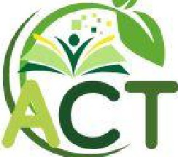

Appendix VII - Top 14 Allergens poster

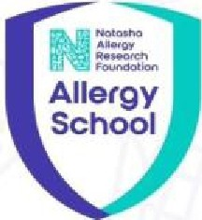
Top 14 Allergens

00

��
Cereals containing gluten
-��
@
Peanuts
Milk
(W�(!)(� )

Molluscs

Natosha Allergy Research Foundation
N
The UK':!i Food Allergy Charity
�

Empower• Include• Protect
-�  l•!d  Sulphur  Dioxide |  | ��  Tree Nuts

AllergySchool.org.uk
C COprrigtl. Z02-4 Tiw Nawh!l "1JlrVy RnMICII Fou'ldll,o,i UK A�.-.dChar1tyNI! 1181C191Salllal>dNa.SC0Sl610







23

