Dear Parents and Carers,
We are very excited to be trialling the new After School Club – there are still some spaces if your child would like opportunity to take part. The club will take place in the school hall every Tuesday and Friday from 3:15 -5Pm. The club will provide the children the chance to take part in a range of sporting activities, keep active and spend time with friends after the school day. Each child will need to bring a water bottle, a piece of fruit will be provided, although you are welcome to send in a small (nut free) snack for your child if you prefer.
Congratulations to our two new Head Girls and Head Boy who are in Y6, I am looking forward to working with them as well as the school council over the coming terms as we look at ways to enhance our school. They all seem to have some great ideas.
Pupils of the week
  - Congratulations to;
  - Van Gogh = Arabella, for working hard all week
  - Monet = Elias, for a brilliant first week at school,
  - Durva for a brilliant first week at school,
  - Elisha for a brilliant first week at school
  - Dali = felicity, for having an excellent attitude to learning

This week’s Attendance
Joint 1st place -Van Gogh & Dali with 100% - AMAZING
3rd Place = Monet with 99%- fabulous
Whole School 99.7% National 95%
I am very proud to announce that we have two Head Girls, Jamiee-Lee & Amelia and one Head Boy – Freddie

  - Our new and Fabulous school council are; Axel, Ronnie, Maria, Sophia and Teegan. Their first meeting is Monday at 12.30pm – don’t forget to wear your badges!


Congratulations to Amelia for being our ‘Excellence Champion’ this week.

👑Headteacher’s Award
Congratulations Amelia (again!) for being the first person to achieve this award this year for a super booklet on The Gambia.

Bikeability 🚴 🚴 🚴
This week’s Bikeability training was a huge success. The children approached the sessions with enthusiasm and determination, successfully completing all the tasks and challenges set for them. Throughout the programme, they developed important cycling skills, learned how to stay safe on the road, and gained a greater understanding of road awareness. We are delighted to say that all the children demonstrated excellent progress and are now more confident and road-aware cyclists. Well done to everyone who took part!
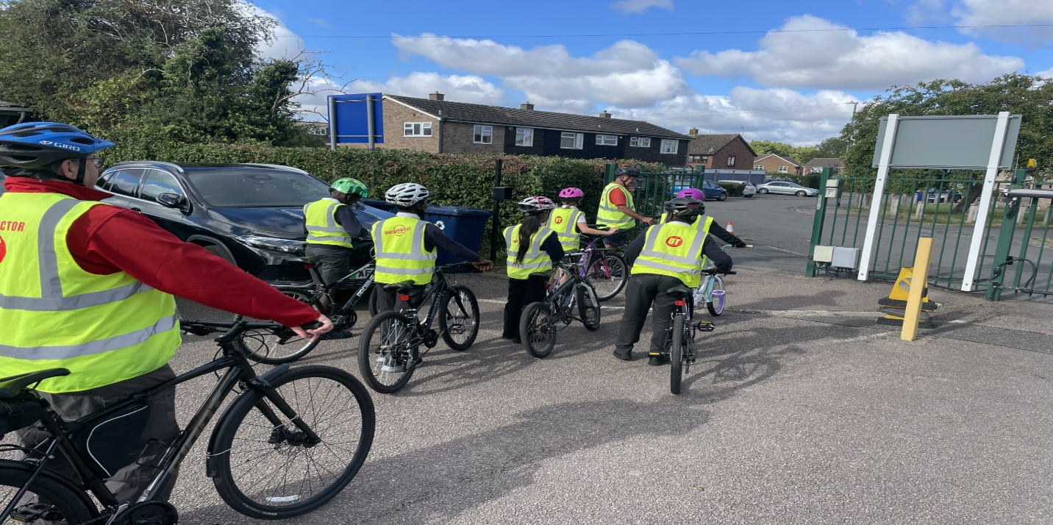

Free School Meals – are you eligible?
https://www.gov.uk/apply-free-school-meals
From the start of term, all pupils who have at least one parent or carer receiving universal credit will be eligible for the meals, regardless of their total household income.
Safeguarding - Playing games together is a great way to learn together and spend time as a family, it can also reduce your anxiety about what your child is doing online! The Family Gaming Database is aimed at helping parents and guardians navigate the world of gaming. https://www.familygamingdatabase.com/en-gb/home
Have a lovely weekend,
Mrs King

Diary Dates
21/09/26 Flu Vaccinations (YR- Y6)
02/10/26 Autumn Disco 5-6pm
21/10/26 Parents Evening 3:30 – 5pm
22/10/26 Parents Evening 4-6pm
26/10/26 – 30/10/26 Half Term
02/11/26 Children return to school
05/11/26 Book Fair
06/11/26 Book Fair
12/11/26 School Photographs
13/11/26 Children in Need – details to follow
27/11/26 Non uniform Day – items for the Tombola
02/12/26 Heights and Weight, YR – Y6
04/12/26 Christmas Fair 3:30 – 4:30pm
08/12/26 2pm Nativity
09/12/26 9.30am Nativity
11/12/26 Film Night – Details to follow
15/12/26 Pantomime in Cambridge
16/12/26 Christmas Jumper Day
Church Service at St Mary’s – time to follow
Christmas Lunch
17/12/26 Class parties
17/12/26 Carols Around the Tree
18/12/26 Finish for Christmas

