Dear Parents and Carers,
Sadly we didn't win the TT Rockstars competition this time, but we are incredibly proud to have been the highest-scoring school, which is a fantastic achievement. A huge well done to all the children who took part and contributed to this amazing result through their hard work, enthusiasm and dedication to practising their times tables. To celebrate this success, everyone will enjoy an extra playtime on Monday. I am so proud of you all!
This Monday, we were pleased to welcome the Cambridgeshire Bike Repairs Service into school. Our older children took part in a practical session where they learned valuable bicycle maintenance skills, including how to carry out safety checks and change a tyre. As part of the visit, all bicycles stored in the school shed received a free check-up, with a note left on each bike explaining whether it was roadworthy or highlighting any repairs that may be needed. This was a fantastic opportunity for the children and, as we head into the colder and wetter months, it is reassuring for families to know that their bicycles are safe and ready to use.
We were delighted to celebrate our Harvest Service on 14th October, led by Fr Paul. It was a lovely service with beautiful singing from the children, and it was wonderful to see so many parents and family members joining us. Thank you to everyone who attended and to all those who generously donated items for the local Food Bank. Your kindness and support will make a real difference to members of our community who need it most.

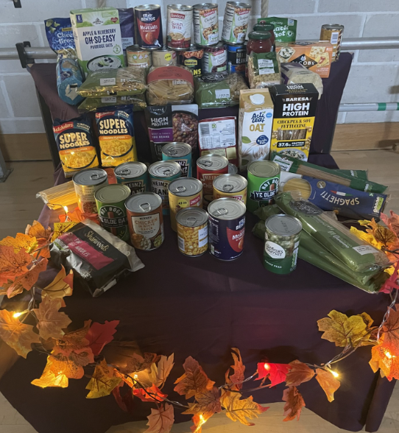

Pupils of the week
  - Congratulations to;
  - Van Gogh = Ariana, For being our ‘top rock’ in TT rockstars.
  - Monet = Evan, for a wonderful effort in all his lessons.
  - Dali = Dash, for using adjectives in his writing.


This week’s Attendance
1st place = Monet 97.3%
2nd Place = Dali 92.8%
3rd Place = Van Gogh 92.3%
Whole School 92.6% National 95%
Oh dear St Mary’s, let’s try and be above National next week!


Congratulations to Freddie for being our ‘Resilience Champion’ this week.

👑Headteacher’s Award
Given to Amelia, for being an amazing friend. Well done!

There has been a request to re-start our coffee mornings and I am hoping the next one will be on Wednesday 4th November – this will be confirmed next week.
Have a wonderful weekend,
Mrs King

Photographs from Monday
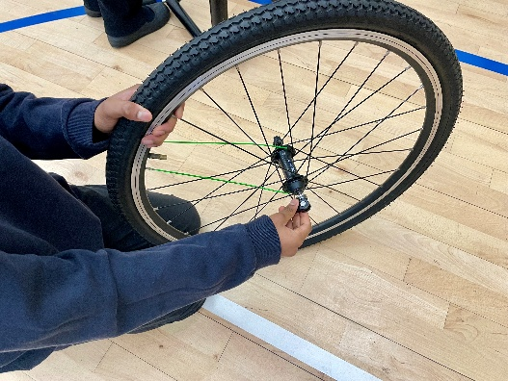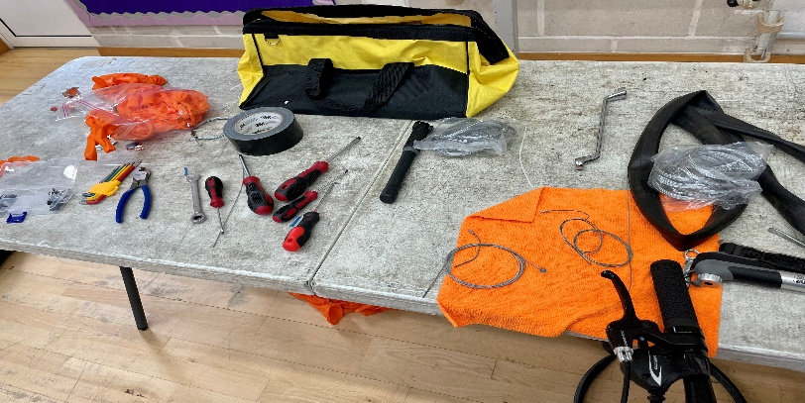
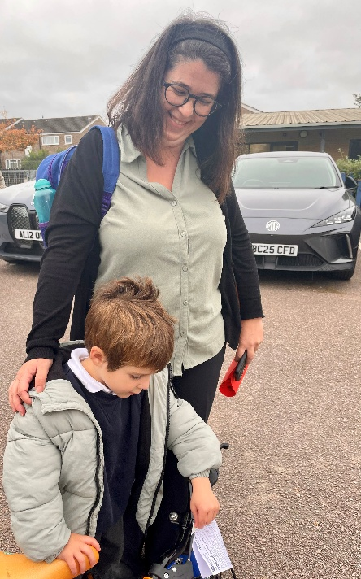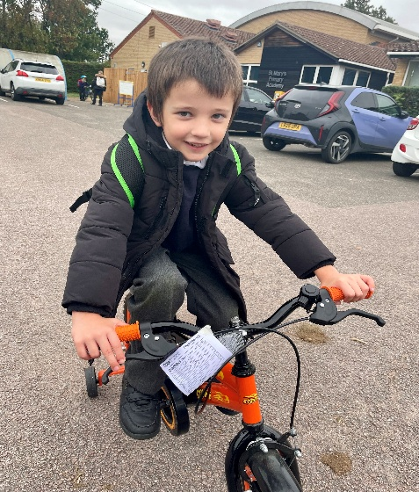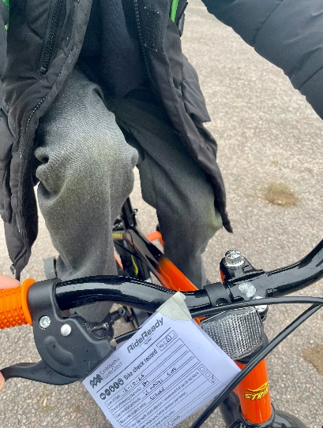
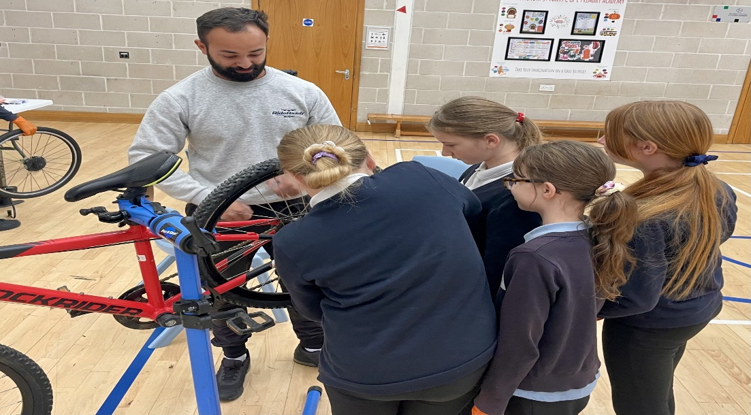

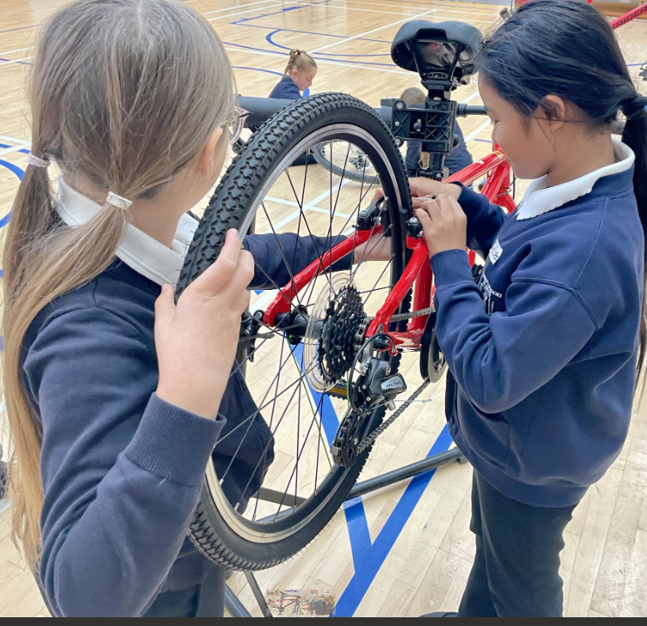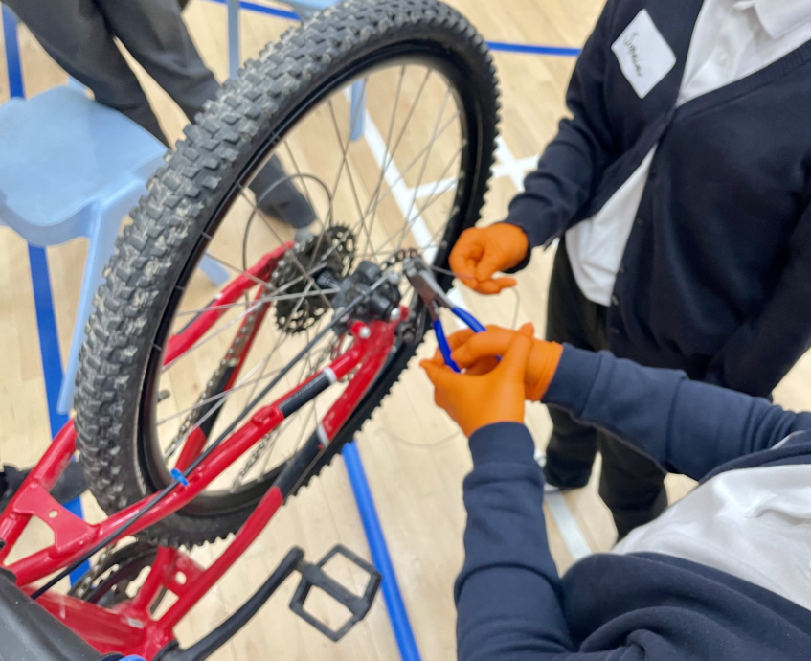
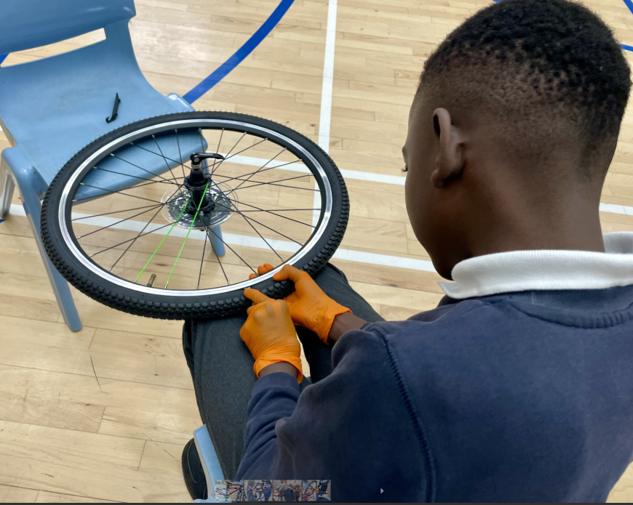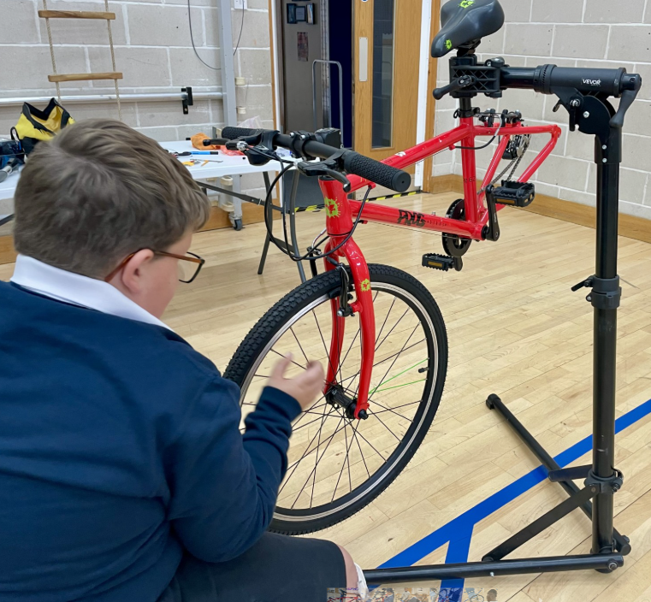
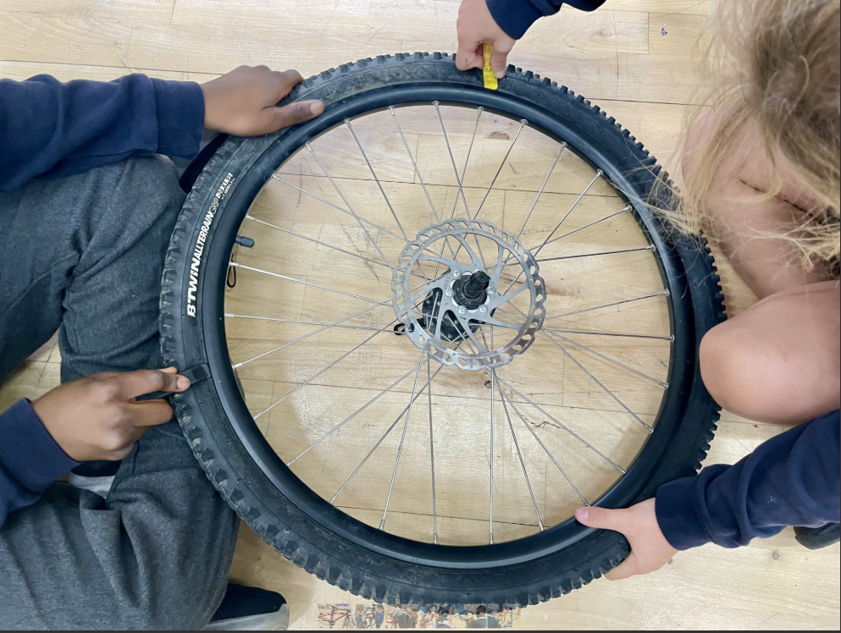
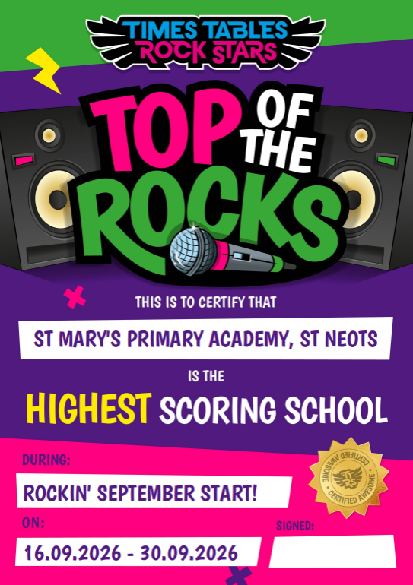
L. King

Diary Dates
21/10/26 Parents Evening 3:30 – 5pm
22/10/26 Parents Evening 4-6pm
23/10/26 FREE Fruity Friday – cheese and crackers or fruit if you don’t like cheese or are dairy free
26/10/26 – 30/10/26 Half Term
02/11/26 Children return to school at normal time
03/11/26 Parents Evening – VG children only
04/11/26 Coffee Morning – T/B/C
05/11/26 Book Fair
06/11/26 Book Fair
12/11/26 School Photographs
13/11/26 Children in Need – details to follow
27/11/26 Non uniform Day – items for the Tombola
02/12/26 Heights and Weight, YR – Y6
04/12/26 Christmas Fair 3:30 – 4:30pm
08/12/26 2pm Nativity
09/12/26 9.30am Nativity
11/12/26 Film Night – Details to follow
15/12/26 Pantomime in Cambridge
16/12/26 Christmas Jumper Day
16/12/26 Church Service at St Mary’s – time to follow
16/12/26 Christmas Lunch
17/12/26 Class parties
17/12/26 Carols Around the Tree
18/12/26 Finish for Christmas


