Dear Parents and Carers,
A huge thank you to all our families for making our Harvest Lunch such a wonderful success. We would also like to extend a special thank you to Claire, our cook, for preparing an amazing lunch, including her famous roast potatoes, which were enjoyed by everyone.
Harvest Service and Food Bank Donations
We are looking forward to welcoming families to our Harvest Service on 14th October at 9:15am, led by Father Paul. Everyone is welcome to attend. As part of our Harvest celebrations, we are asking children to bring in donations for the local Food Bank. Please see the suggested donation ideas below. Every contribution, no matter how small, will be greatly appreciated and will help support those in our community who need it most.
Suggested donations include:
- Tinned vegetables, fruit, meat or fish
- Soup and baked beans
- Pasta, rice and noodles
- Breakfast cereals
- Tea, coffee and long-life milk
- Biscuits and crackers
- Jams and spreads
- New toiletries and household essentials

I have spoken to Mrs Powell this week, she is missing you all and sends her very best wishes to everyone. 

McMillan Coffee Afternoon
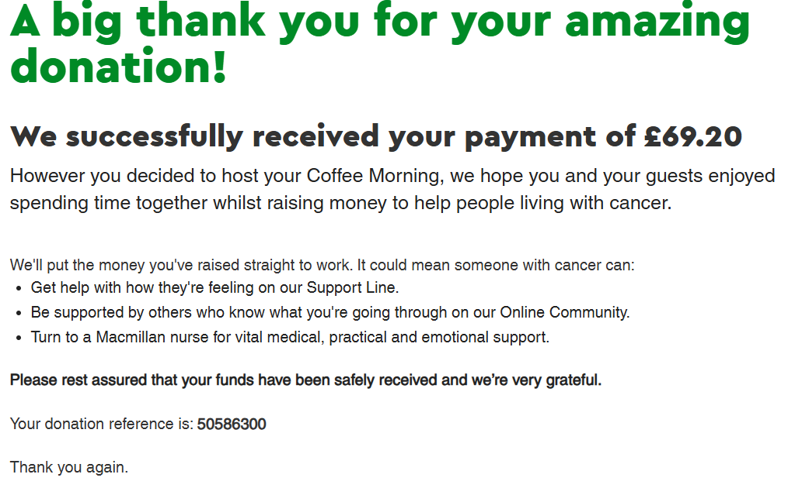
Pupils of the week
  - Congratulations to;
  - Van Gogh = Talin & Arabella for consistently reading regularly at home
  - Monet = Sienna, for improved focus
  - Dali = Talia for excellent focus and beautiful presentation


This week’s Attendance
1st place = Van Gogh 95.8%
2nd Place = Monet 93.2%
3rd Place = Dali 91.8%
Whole School 93.5% National 95%

Congratulations to Axel for being our ‘Respect Champion’ this week.
👑Headteacher’s Award
Congratulations to Axel for helping Mrs King during computing.
- Tips for Better "Wind-Down" Transitions from the NSPCC
If your child uses VR, paediatricians suggest a few ground rules to protect their sleep and development:
- The 2-Hour Rule: Power down the headset at least two hours before bedtime.
- Keep Sessions Short: Limit active play to 10–15 minutes per session for younger users.
- The Reality Reset: When the session ends, have your child sit quietly, take deep breaths, and focus on physical objects in the room to help their central nervous system reset.

Have a joyful weekend,
Mrs King

Diary Dates
14/10/26 Harvest Service led by Fr Paul 9am – everyone welcome
16/10/26 Fruity Friday – Frubes are back by popular demand!
21/10/26 Parents Evening 3:30 – 5pm
22/10/26 Parents Evening 4-6pm
23/10/26 FREE Fruity Friday – cheese and crackers or fruit if you don’t like cheese or are dairy free
26/10/26 – 30/10/26 Half Term
02/11/26 Children return to school at normal time
03/11/26 Parents Evening – VG children only
05/11/26 Book Fair
06/11/26 Book Fair
12/11/26 School Photographs
13/11/26 Children in Need – details to follow
27/11/26 Non uniform Day – items for the Tombola
02/12/26 Heights and Weight, YR – Y6
04/12/26 Christmas Fair 3:30 – 4:30pm
08/12/26 2pm Nativity
09/12/26 9.30am Nativity
11/12/26 Film Night – Details to follow
15/12/26 Pantomime in Cambridge
16/12/26 Christmas Jumper Day
16/12/26 Church Service at St Mary’s – time to follow
16/12/26 Christmas Lunch
17/12/26 Class parties
17/12/26 Carols Around the Tree
18/12/26 Finish for Christmas


