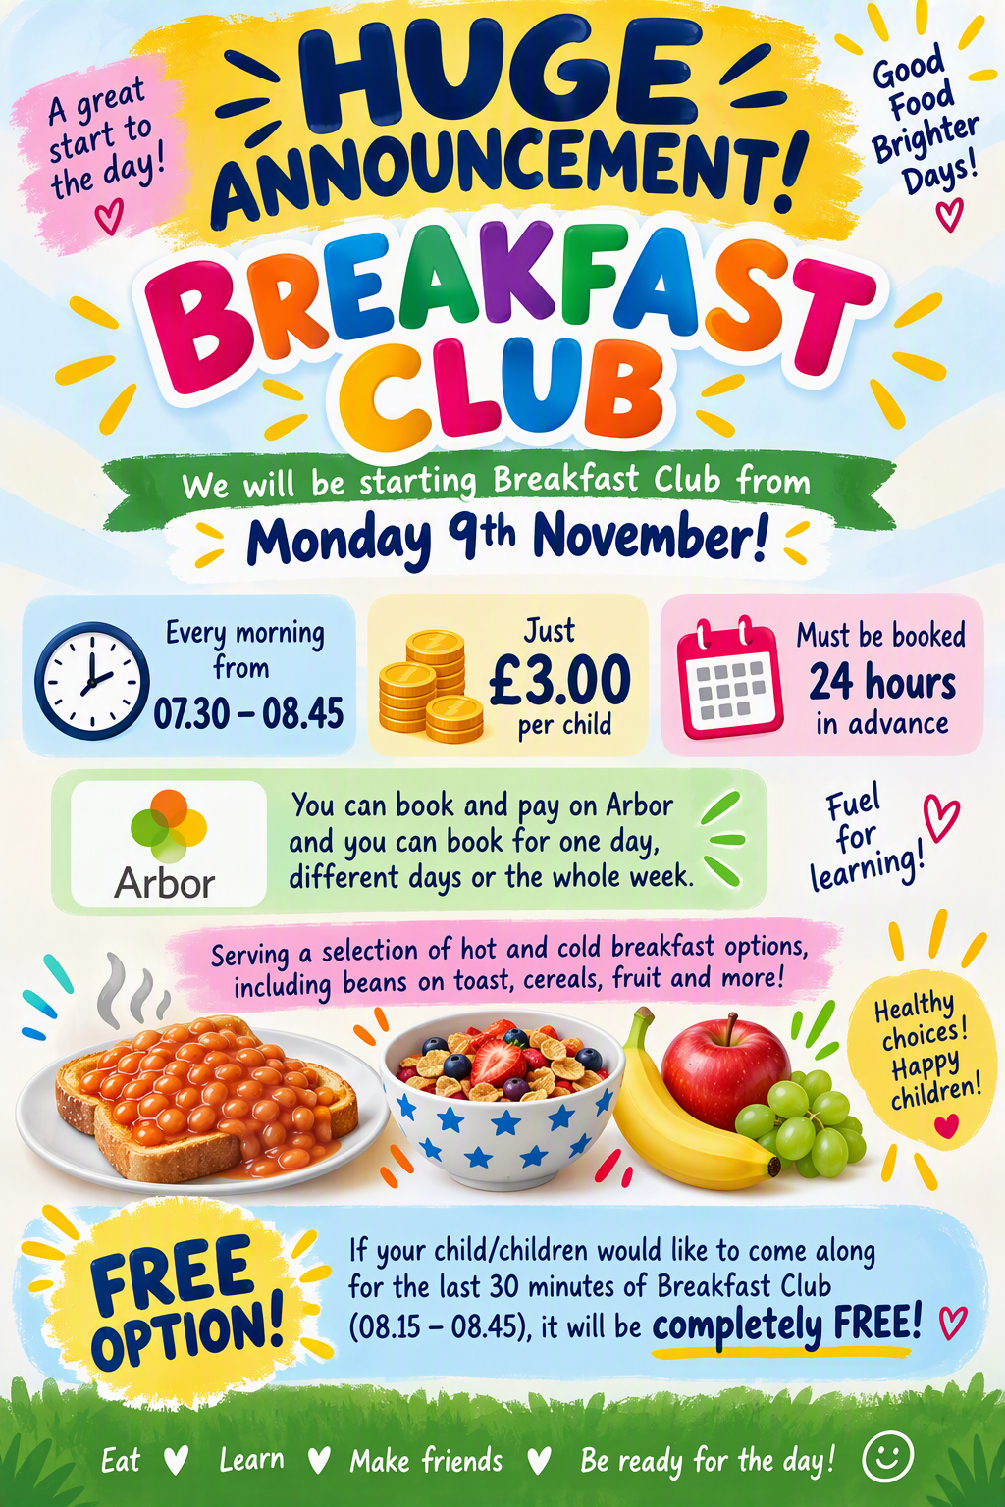
Pupils of the week
  - Congratulations to;
  - Van Gogh = Somken, for amazing ARTWORK
  - Monet = Axel, for fabulous work in English
  - Dali = Oscar, for a great week of learning and following instructions

This week’s Attendance

1st place = Van Gogh 98.8%
2nd Place = Monet 94.4%
3rd Place = Dali 92.4%
Whole School 92.6% National 95%
Not our best week St Mary’s, but congratulations to Van Gogh, - I think you have won a non-uniform day after half term. Mrs P will give you the date.


Congratulations to Amelia for being our ‘Excellence’ Champion’ this week.

The children have had an amazing time at PGL and I would like to thank the staff for being so generous with their time and bringing them all back safely.
It has again been a huge success, and the children are already talking about their next visit and extending their stay from two nights to three! They have embraced every opportunity and thrown themselves into a wide range of exciting activities, including the zip wire, canoeing, high ropes, the giant swing, problem-solving challenges, and even basketball on a trampoline.
Alongside all the adventure and excitement, the children have enjoyed spending quality time with their friends and making new friendships. It has been wonderful to see their confidence grow as they challenge themselves, support one another, and create memories that will last a lifetime. We are incredibly proud of their enthusiasm, resilience, and positive attitude throughout the trip. What a fantastic experience it has been for everyone involved!
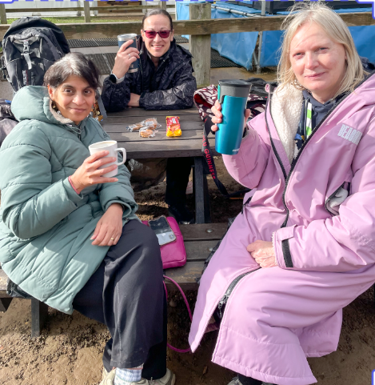
There has been a request to restart our coffee mornings. Our next coffee morning will take place on Wednesday 4th November, straight after Fr Paul's worship at 9am, which you are all very welcome to attend. Please come along for a chat, a cup of tea or coffee, and of course, a biscuit or two! We look forward to seeing you there.
Have a fabulous half term,
Mrs King
Diary Dates
L. King
02/11/26 Children return to school at normal time
03/11/26 Parents Evening – VG children only
04/11/26 Worship and Coffee Morning, 9am
05/11/26 Book Fair
06/11/26 Book Fair
12/11/26 School Photographs
13/11/26 Children in Need – details to follow
27/11/26 Non uniform Day – items for the Tombola
02/12/26 Heights and Weight, YR – Y6
04/12/26 Christmas Fair 3:30 – 4:30pm
08/12/26 2pm Nativity
09/12/26 9.30am Nativity
11/12/26 Film Night – Details to follow
15/12/26 Pantomime in Cambridge
16/12/26 Christmas Jumper Day
16/12/26 Church Service at St Mary’s – time to follow
16/12/26 Christmas Lunch
17/12/26 Class parties
17/12/26 Carols Around the Tree
18/12/26 Finish for Christmas


