Dear Parents and Carers,
I can’t believe we are already at the end of another week. Time is flying by, and before we know it, we will be putting up the Christmas decorations!
The children have all been working incredibly hard this week. It has been wonderful to see so many of them being sent to the office to share their excellent work and achievements. I also had the pleasure of spending some time in Van Gogh Class this week whilst they were taking part in a debate. Their enthusiasm, confidence, and thoughtful contributions were fantastic to see.
We are delighted to be heading to the pantomime on 15th December 2026, leaving school promptly at 9:00am. If you would like your child to attend, the cost is £20.00, which can be paid via Arbor. Please note that any Nursery children wishing to attend must be accompanied by an adult. We are all very excited about this special festive trip and look forward to enjoying the performance together.
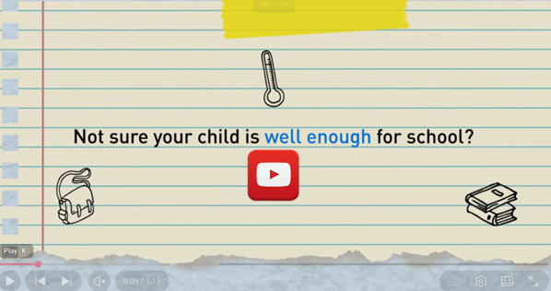
  - https://www.nhs.uk/live-well/is-my-child-too-ill-for-school/?es_c=E67082EC531EC5FDD79771D1C96B3D81&es_cl=4752CB2B6311FF3A3ECB3F4B0BD0D00B&es_id=ph7%c2%a3o1

Pupils of the week
  - Congratulations to;
  - Van Gogh = Simona, for lovely debating skills
  - Monet = zaeem, for great use of maths language
  - Dali = brodie, for excellent learning in English and maths


This week’s Attendance
1st place =Van Gogh 94%
2nd Place = Monet 93%
3rd Place = Dali 91%
Whole School 93.7% National 95%
Come on St Mary’s lets get our attendance above National!

Congratulations to Chelsea for being our ‘Courageous Champions’ this week.
👑Headteacher’s Award
Congratulations to Dominic for super participation every Monday during my Worship!
Have a fabulous weekend,
Mrs King
Diary Dates
02/10/26 Autumn Disco 5:15 – 6:15pm,
07/10/26 Harvest Lunch 12:20pm – please book through the office by Monday 5th October 2026
09/10/26 Fruity Friday - Watermelon
14/10/26 Harvest Service led by Fr Paul 9am
16/10/26 Fruity Friday
21/10/26 Parents Evening 3:30 – 5pm
22/10/26 Parents Evening 4-6pm
23/10/26 FREE Fruity Friday – cheese and crackers or fruit if you don’t like cheese or are dairy free
26/10/26 – 30/10/26 Half Term
02/11/26 Children return to school at normal time
03/11/26 Parents Evening – VG children
05/11/26 Book Fair
06/11/26 Book Fair
12/11/26 School Photographs
13/11/26 Children in Need – details to follow
27/11/26 Non uniform Day – items for the Tombola
02/12/26 Heights and Weight, YR – Y6
04/12/26 Christmas Fair 3:30 – 4:30pm
08/12/26 2pm Nativity
09/12/26 9.30am Nativity
11/12/26 Film Night – Details to follow
15/12/26 Pantomime in Cambridge
16/12/26 Christmas Jumper Day
Church Service at St Mary’s – time to follow
Christmas Lunch
17/12/26 Class parties
17/12/26 Carols Around the Tree
18/12/26 Finish for Christmas


